

Faculty oF information AND COMMUNICATION technology
PRINCIPLES OF STRUCTURED PROGRAMMING

Title : Final Project
Due Date : Week 12
Semester/Year : 2/1
Lecturer : MR. Mohamed Lamin Kamara
Class : DIT1201F
NO. | Name | Surname | ID | SIGN
1 | PRINCE M’BAYINGA KABIA
2 | CHERNOR SULAIMAN BAH
3 | FATIMA BRIDGETTE BARRIE

Academic Honesty Policy Statement
We, hereby attest that contents of this attachment are my own work. Referenced works, articles, art, programs, papers or parts thereof are acknowledged at the end of this paper. This includes data excerpted from CD-ROMs, the Internet, other private networks, and other people’s disk of the computer system.

Submitting Person’s Signature : Date: 24th/6/2026
(If submission is for a group work, all students’ names MUST appear above and put down their signatures here)

LECTURER’S COMMMENTS/GRADE: | for office use only upon receive  Remark  DATE :  TIME :  RECEIVER’S NAME :

Table of Contents
Introduction………………………………………………………………………………………………………1
2. Problem Definition 2
3. Software Development Life Cycle (SDLC) 3
Chosen SDLC Model: Agile Methodology 3
SDLC Phases for SHAS 3
Phase 1: Planning 3
Phase 2: Requirements Analysis 4
Phase 3: System Design 4
Phase 4: Implementation (Development) 4
Phase 5: Testing 4
Phase 6: Deployment 5
Phase 7: Maintenance 5
4. System Architecture Design 6
Architecture Layers 6-7
5. UML Diagrams 8
5.1 Use Case Diagram 9
Class Diagram 10
5.3 Sequence Diagram – Book Appointment 11
6. System Description 13
Key Features 13
User Interaction Workflow 13
Expected Benefits 14
7. Prototype Development (UI/UX Design) 15
9. Project Management 17
Project Plan Overview 18
Gantt Chart 18
Network Diagram (Critical Path) 19
10. License, Design Quality & SDG Relevance 19
Design Quality (UI/UX) 19
10 SDG Alignment 21
11. Conclusion 22
12. References 23

Introduction

Digital Public Goods (DPGs) are digital solutions such as software, data systems, artificial intelligence systems, and open standards that are designed to solve real-world problems for the benefit of society.

In Sierra Leone, many patients still face difficulties accessing quality healthcare because of long distances to the nearest health facility, lack of information about available services, inadequate medical record-keeping and poor channels of communication between patients and healthcare providers. These systemic gaps result in delayed treatment, preventable deaths, and an overburdened healthcare infrastructure.
This project presents the Smart Health Access System (SHAS), a Digital Public Good designed to connect patients, doctors, clinics, and public health administrators through a simple digital platform. The system supports SDG 3: Good Health and Well-being.

This report documents the full Software Development Life Cycle (SDLC) process applied to SHAS, including system architecture, UML diagrams, prototype design, project management planning, licensing considerations and SDG alignment.
1

2. Problem Definition
Background of the Problem

Sierra Leone ranks among the countries with the lowest healthcare access indices globally. According to the World Health Organization, the country suffers from a critical shortage of healthcare professionals, with fewer than 0.2 physicians per 1,000 people. The majority of healthcare facilities are concentrated in Freetown and other rural centers leaving urban populations underserved.

Key barriers to healthcare access include:
- Shortage of healthcare facilities, especially in rural districts
- Long travel distances to reach clinics and hospitals
- Lack of medical information systems for tracking patient records
- Poor communication between patients and healthcare providers
- Inefficient appointment scheduling leading to long wait times
- Limited awareness of available health services

Target Users
- Patients (especially those in rural and peri-urban areas)
- Doctors, nurses, and other healthcare workers
- Hospital and clinic administrators
- Ministry of Health personnel and public health officials
2

3. Software Development Life Cycle (SDLC)

Chosen SDLC Model: Agile Methodology
SHAS will be developed using the Agile Software Development methodology, specifically the Scrum framework. Agile was selected because it supports iterative development, rapid feedback loops, and continuous improvement all of which are essential for a system that must adapt to evolving healthcare needs and user feedback in a dynamic environment like Sierra Leone.

Agile allows the team to deliver functional increments of SHAS at the end of each sprint (2-week cycles), enabling early testing and stakeholder feedback before full deployment.

SDLC Phases for SHAS

Phase 1: Planning
During the planning phase, the team conducted stakeholder meetings with healthcare workers, patients, and hospital administrators to identify system requirements. A project scope was defined, a Gantt chart was produced, and key risks were identified. Resources, timelines, and team roles were assigned.

- Stakeholder identification and engagement
- Feasibility study and resource assessment
- Definition of project scope and constraints
- Risk analysis and mitigation planning

Phase 2: Requirements Analysis
Functional and non-functional requirements were gathered through interviews, surveys, and observation of current healthcare workflows. Use case diagrams and user stories were developed to document how different actors interact with the system.

- Functional requirements: appointment booking, patient records, notifications, doctor-patient messaging
- Non-functional requirements: security, scalability, usability, reliability, performance
- User stories created for each actor (Patient, Doctor, Admin)
3

Phase 3: System Design
The system architecture was designed, including the database schema, API structure, and UI/UX wireframes. UML diagrams (Use Case, Class, Sequence, Activity) were developed to model system behaviour and relationships. Technology stack decisions were made.

- System architecture diagram (3-tier: Presentation, Business Logic, Data Layer)
- UML Class Diagram, Use Case Diagram, Sequence Diagram, Activity Diagram
- Database schema design (MySQL)
- UI/UX wireframes using Figma (10+ screens)

Phase 4: Implementation (Development)
Development follows Scrum sprints. The frontend is built using React.js for a responsive web interface, and the backend uses Node.js with Express. The database is MySQL. The codebase is hosted on GitHub with version control.

- Sprint 1: User authentication and registration module
- Sprint 2: Doctor listing and appointment booking
- Sprint 3: Medical records management
- Sprint 4: Notification and messaging system
- Sprint 5: Admin dashboard and reporting

Phase 5: Testing
Each sprint includes unit testing, integration testing, and user acceptance testing (UAT). Bugs are logged and resolved before the next sprint. Performance testing ensures the system handles concurrent users.

- Unit testing: individual module functionality
- Integration testing: module interactions and API calls
- User Acceptance Testing (UAT): real users validate expected behaviour
- Security testing: input validation, authentication, data encryption

4

Phase 6: Deployment
SHAS is deployed on a cloud platform (AWS or DigitalOcean) to ensure high availability and scalability. A staging environment is used before production release. Continuous Integration/Continuous Deployment (CI/CD) pipelines automate deployment.

Phase 7: Maintenance
Post-deployment, the team monitors system performance, fixes bugs, and releases updates based on user feedback. Regular security patches are applied, and the system is scaled as the user base grows.

Phase | Key Activities | Output/Deliverable
1. Planning | Stakeholder meetings, feasibility, risk analysis | Project plan, Gantt chart
2. Requirements | Interviews, user stories, use cases | SRS document, Use Case Diagram
3. Design | Architecture, UML, UI/UX wireframes | System design document, Figma prototype
4. Implementation | Coding in sprints, GitHub commits | Working software increments
5. Testing | Unit, integration, UAT, security | Test reports, bug fixes
6. Deployment | Cloud hosting, CI/CD pipeline | Live system
7. Maintenance | Monitoring, updates, user feedback | Patch releases, improvements
5

4. System Architecture Design
SHAS follows a three-tier client-server architecture. The Presentation Layer provides the user interface, the Business Logic Layer processes requests and rules, and the Data Layer stores persistent information.

Architecture Layers
Tier 1: Presentation Layer (Frontend)
The frontend is a web-based application built with React.js, providing a responsive user interface accessible via desktop and mobile browsers. Key screens include patient registration, doctor search, appointment booking, medical records, and notifications.

- Technology: React.js, HTML5, CSS3, Tailwind CSS
- Accessed via web browser (Chrome, Firefox, Safari)
- Responsive design for mobile and desktop

Tier 2: Business Logic Layer (Backend/API)
The backend is a RESTful API built with Node.js and Express.js. It processes all business logic: user authentication, appointment scheduling, record management, and notification dispatch. It communicates with the frontend via HTTP/HTTPS and with the database via a MySQL connector.

- Technology: Node.js, Express.js
- RESTful API with JSON data exchange
- JWT-based authentication and authorisation
- Email/SMS notification via third-party APIs (Twilio, SendGrid)

Tier 3: Data Layer (Database)
MySQL is used as the relational database management system. It stores all persistent data: user accounts, patient records, doctor profiles, appointments, and audit logs. The database is hosted on a managed cloud service for security and reliability.

- Technology: MySQL 8.0
- Hosted on AWS RDS or DigitalOcean Managed Database
- Regular automated backups
- Encrypted at rest and in transit
6

Component Interaction
The user opens the SHAS web application in a browser (Presentation Layer). When a patient books an appointment, the browser sends an HTTP POST request to the backend API (Business Logic Layer). The API validates the request, checks doctor availability in the database (Data Layer), saves the appointment, and returns a confirmation response. The frontend then displays the confirmation to the user, and a notification is sent via email/SMS.

Component | Technology | Role
Frontend | React.js | User interface, data display, form handling
Backend API | Node.js + Express | Business logic, request processing, authentication
Database | MySQL | Data persistence and storage
Notification Service | Twilio / SendGrid | SMS and email alerts
Cloud Hosting | AWS / DigitalOcean | Infrastructure, scalability, availability
Version Control | GitHub | Source code management and collaboration
7

5. UML Diagrams

Use Case Diagram
The Use Case Diagram below illustrates the interactions between the three primary actors (Patient, Doctor, and Admin) and the SHAS system. It identifies the key use cases that the system must support.

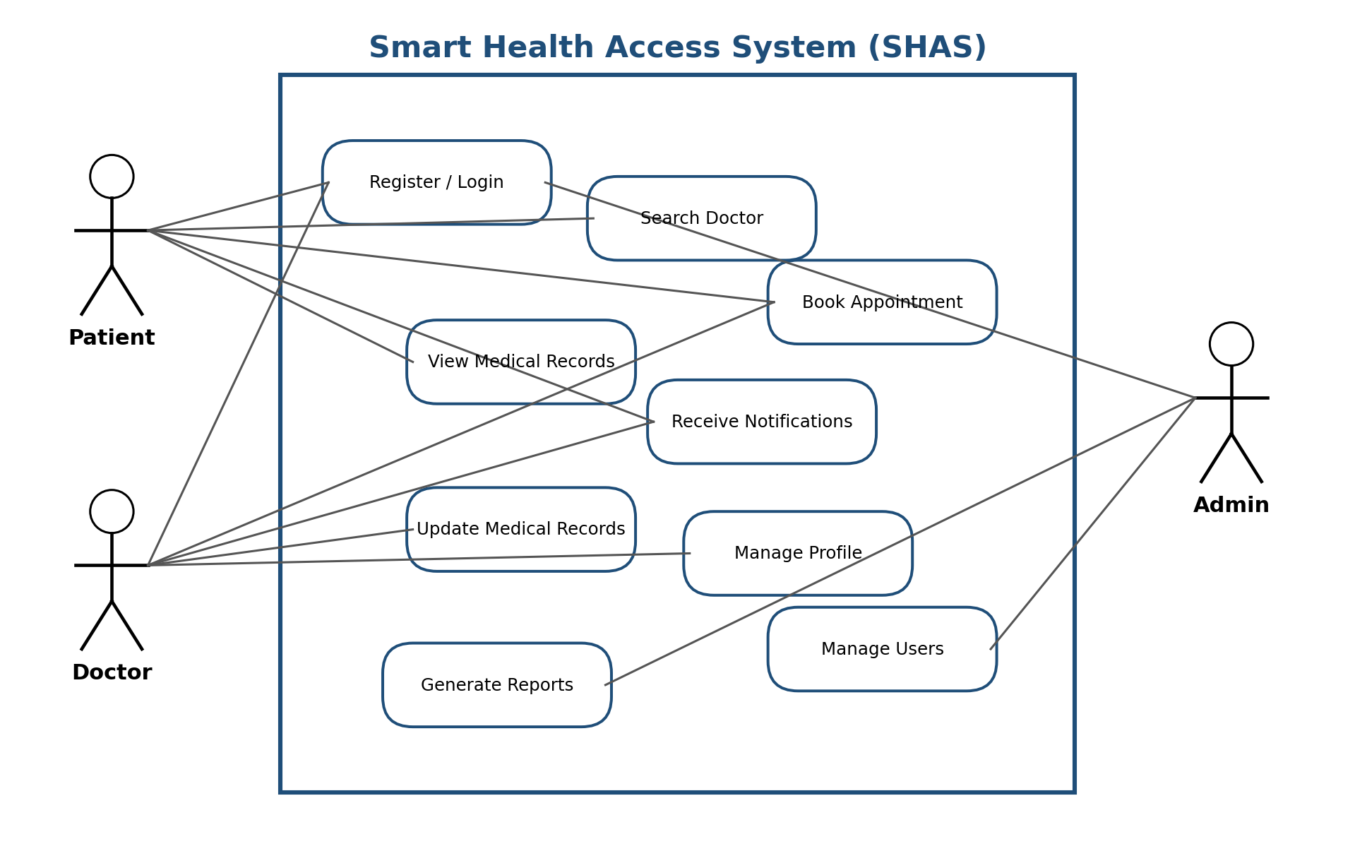

8

Class Diagram
The Class Diagram models the core entities in the SHAS system and their relationships. The main classes are:
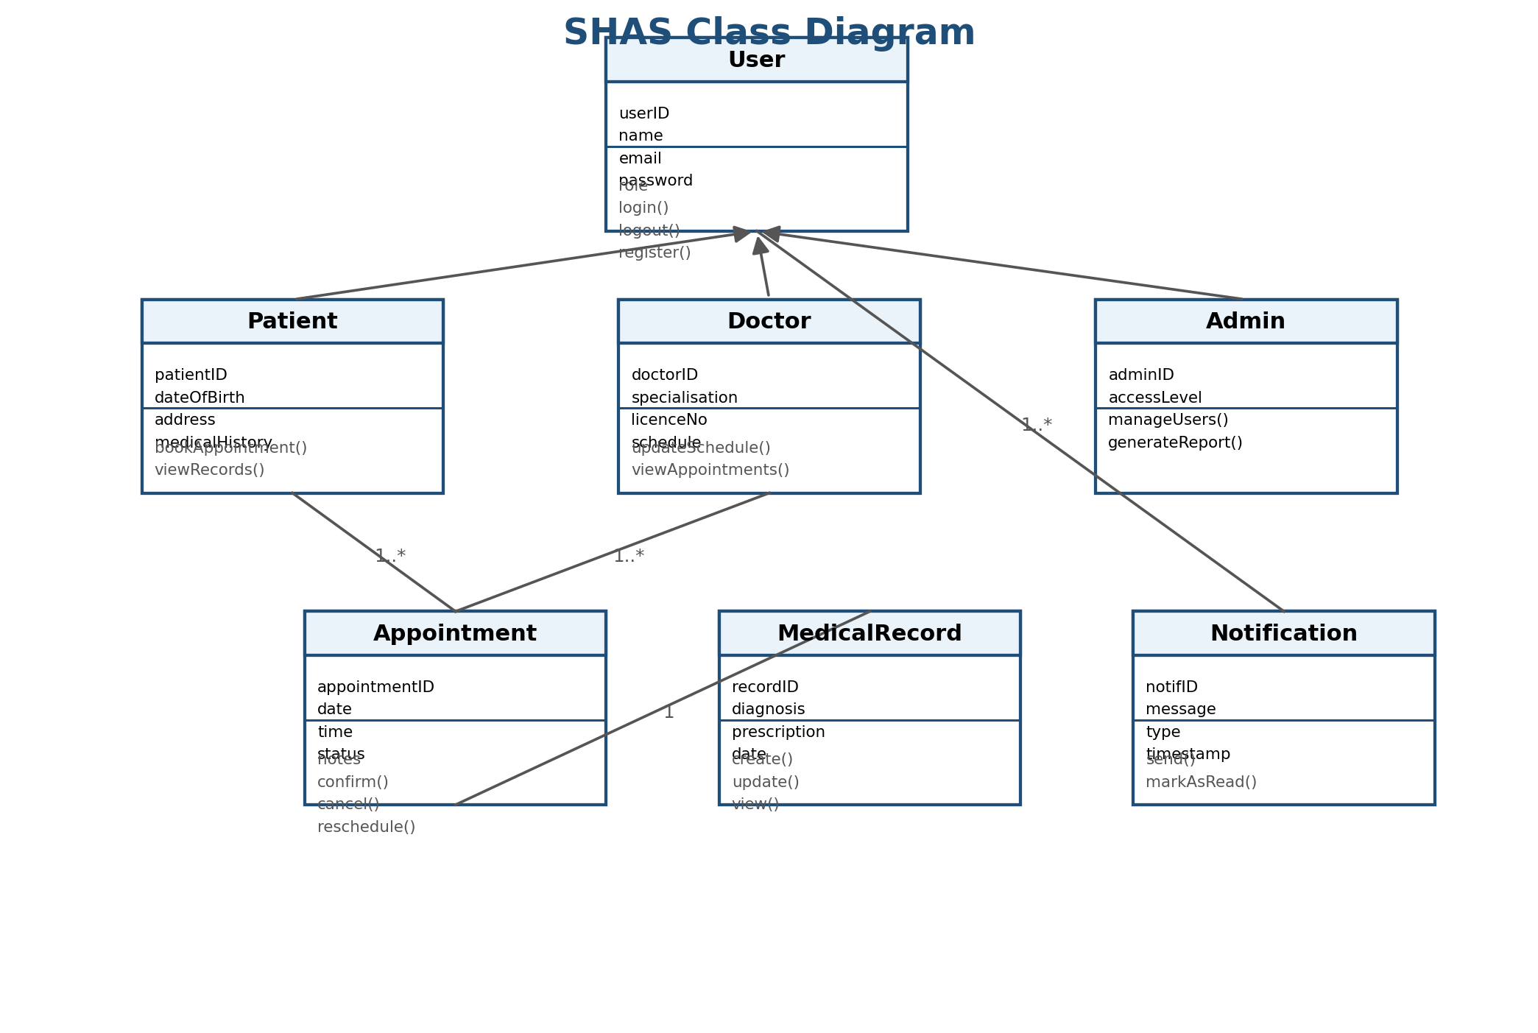
9

5.3 Sequence Diagram – Book Appointment
The sequence diagram below describes the step-by-step interaction between system components when a patient books an appointment:

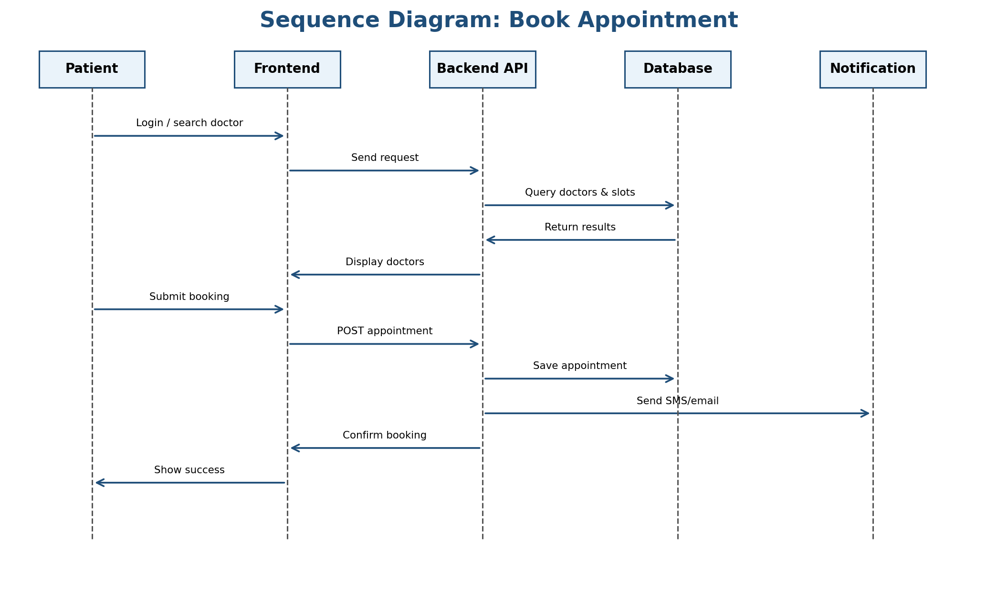

10
Activity Diagram – Patient Registration and Login

The activity diagram models the workflow a new patient follows to register and log into SHAS:

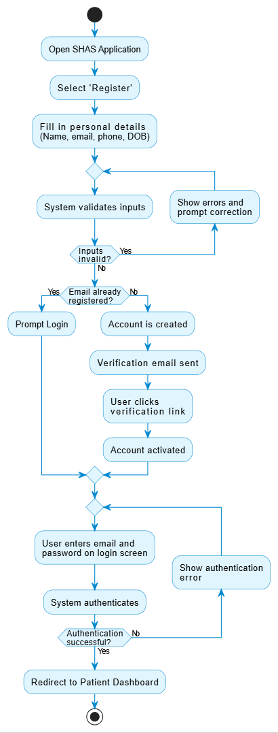
11

6. System Description
System Name and Purpose
System Name: Smart Health Access System (SHAS)
Purpose: To provide patients in Sierra Leone with easy, fast, and reliable digital access to healthcare services, reducing barriers caused by distance, lack of information, and inefficient manual processes.

Key Features
Feature | Description
User Registration & Login | Secure account creation and authentication for patients, doctors, and admins using email/password and JWT tokens.
Doctor Search & Directory | Patients can search for doctors by name, specialisation, location, or availability.
Online Appointment Booking | Patients select a preferred doctor, choose an available time slot, and receive instant booking confirmation.
Digital Medical Records | Doctors create and update patient records. Patients can securely view their own medical history, diagnoses, and prescriptions.
Health Notifications & Alerts | Automated SMS and email reminders for upcoming appointments, medication schedules, and health tips.
Doctor-Patient Messaging | Secure in-app messaging channel between patients and their assigned doctors.
Emergency Contact Support | A dedicated emergency button connects patients to the nearest emergency line or healthcare facility.
Admin Dashboard | Administrators monitor system usage, manage user accounts, and generate statistical reports for health authorities.

User Interaction Workflow
The typical workflow for a patient using SHAS is as follows:
- Step 1: Patient opens the SHAS web application and registers or logs in
- Step 2: Patient searches for a doctor or specialist
- Step 3: Patient selects an available appointment slot and confirms booking
- Step 4: System sends confirmation notification (SMS + email)
- Step 5: Patient attends consultation (in-person or via telemedicine)
- Step 6: Doctor updates the patient's medical record in the system
- Step 7: Patient receives post-consultation summary and any follow-up reminders
12

Expected Benefits
- Faster and easier access to healthcare services for all patients
- Reduced waiting times at clinics and hospitals
- Better management and continuity of patient medical records
- Improved communication between patients and healthcare providers
- Early diagnosis and treatment through timely reminders and follow-ups
- More efficient use of healthcare resources
13

7. Prototype Development (UI/UX Design)
Design Tool
The SHAS prototype was designed using Figma, a collaborative interface design tool. The design follows a clean, accessible, and user-friendly approach appropriate for users in Sierra Leone, including those with limited digital literacy.

Design Principles
- Simplicity: minimal UI elements, clear navigation, and straightforward language
- Accessibility: high-contrast colours, readable font sizes, and icon-based navigation
- Consistency: uniform colour scheme (blue and white), typography, and button styles throughout
- Mobile-first: designed for smartphone screens, the primary device for most users

Screen Designs
Screen | Screen Name | Description
1 | Splash / Welcome Screen | App logo, tagline 'Your Health, Our Priority', Get Started button
2 | Patient Registration | Form: full name, email, phone, date of birth, password, register button
3 | Login Screen | Email and password fields, Login button, 'Forgot Password' link
4 | Patient Dashboard | Welcome message, upcoming appointments, quick-access buttons (Book, Records, Messages)
5 | Doctor Search | Search bar, filters (specialisation, location), list of doctor cards with photo and rating
6 | Doctor Profile | Doctor photo, name, specialisation, bio, available time slots, 'Book Appointment' button
7 | Appointment Booking | Calendar date picker, time slot selector, optional notes, Confirm button
8 | Booking Confirmation | Success message, appointment summary, add-to-calendar option, Share option
9 | Medical Records | List of past consultations, diagnoses, prescriptions; filter by date
10 | Notifications / Alerts | Timeline of system notifications: appointment reminders, health tips, messages

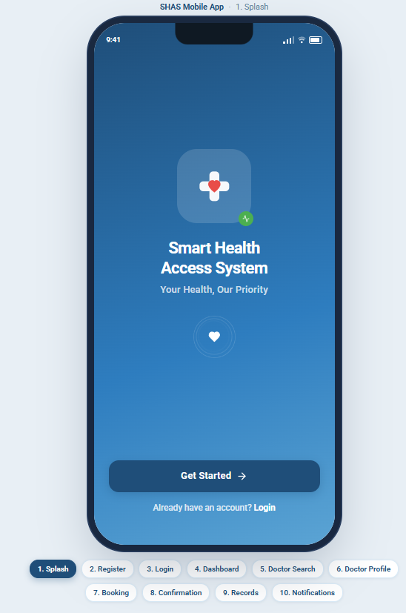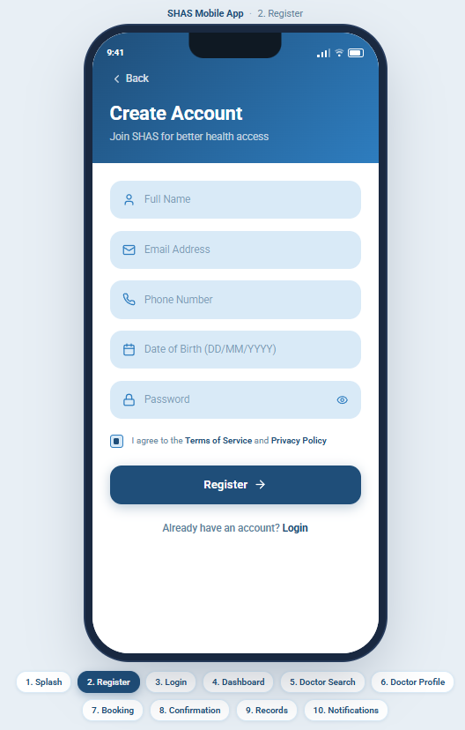
14
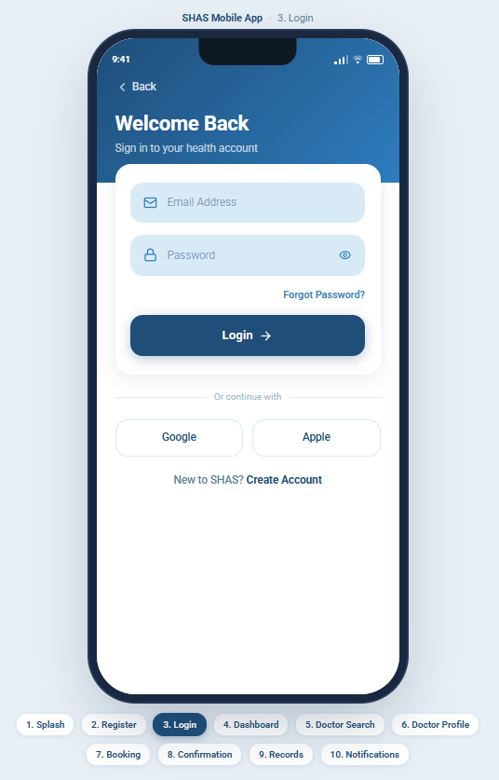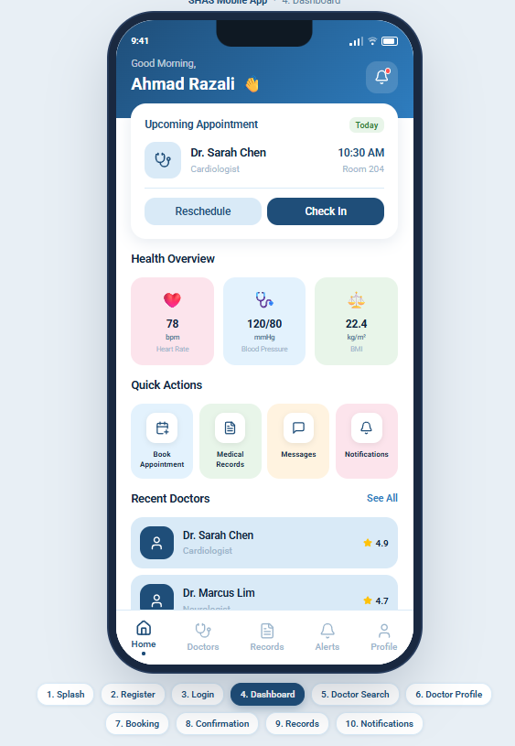
15

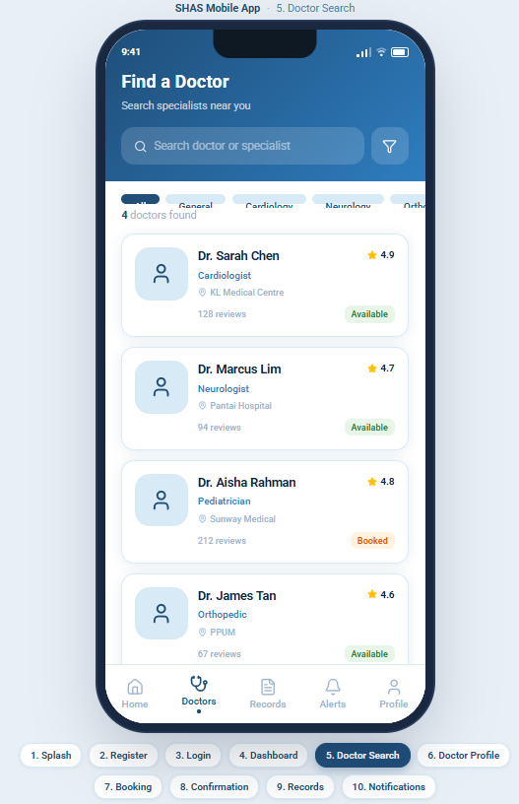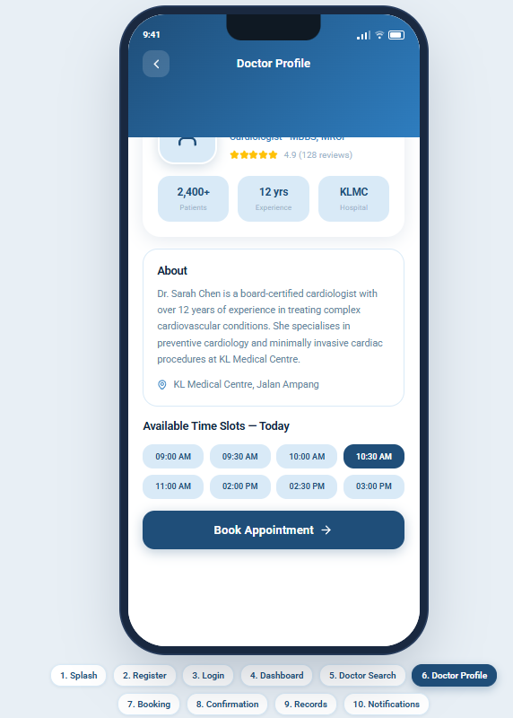

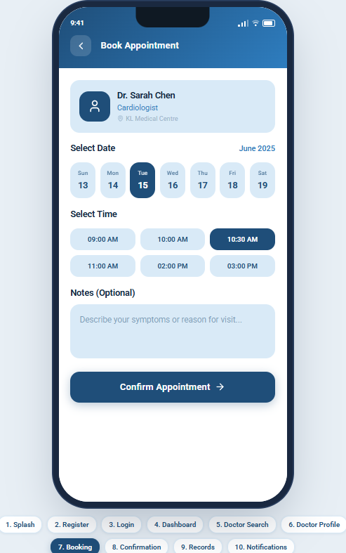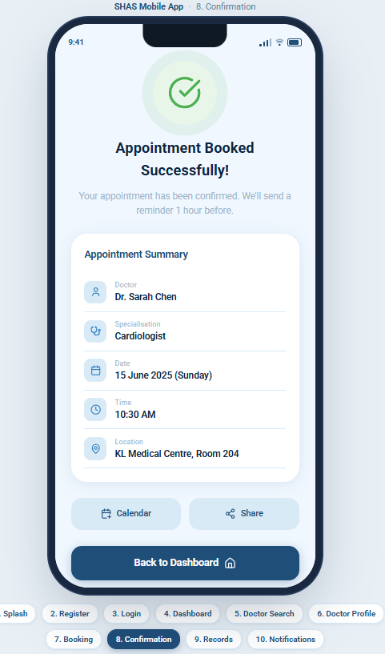

16

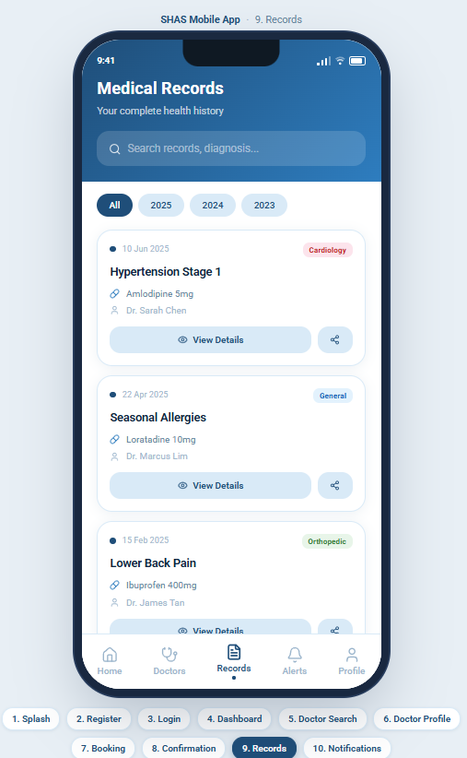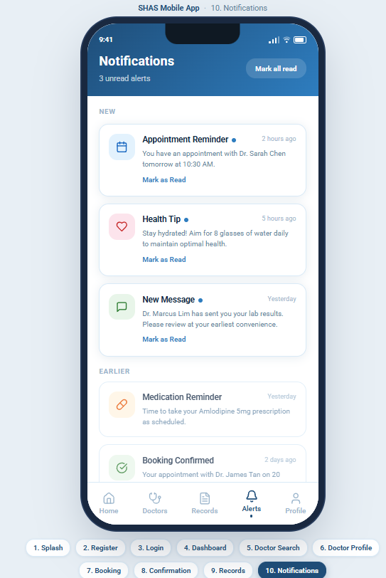

9. Project Management

Project Plan Overview
The project runs from Week 4 to Week 11 (8 weeks). The team follows Scrum with 2-week sprints. Key milestones are aligned with the academic calendar.

Gantt Chart
17
Task / Activity | Wk 4 | Wk 5 | Wk 6 | Wk 7 | Wk 8 | Wk 9 | Wk 10 | Wk 11
Planning & Requirements | ██ | ██
System Design & UML |  | ██ | ██
UI/UX Prototype (Figma) |  |  | ██ | ██
Backend Development |  |  | ██ | ██ | ██
Frontend Development |  |  |  | ██ | ██ | ██
Testing & QA |  |  |  |  | ██ | ██
GitHub Setup & Integration | ██ | ██ | ██ | ██ | ██ | ██ | ██
Report Documentation |  |  |  |  | ██ | ██ | ██
Final Review & Submission |  |  |  |  |  |  | ██ | ██

Network Diagram (Critical Path)
The network diagram identifies task dependencies and the critical path for SHAS development..
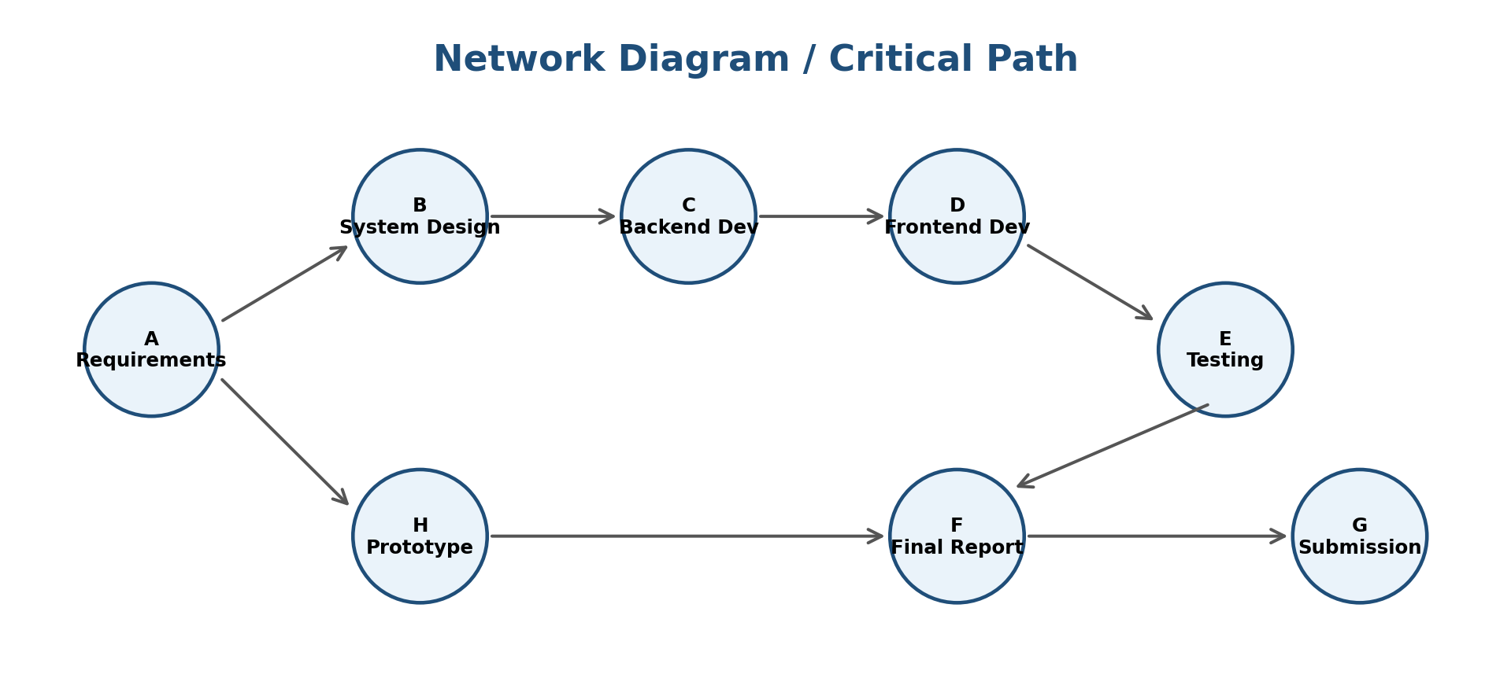
18

10. License, Design Quality & SDG Relevance
Software License
SHAS is released under the MIT License, one of the most permissive and widely used open-source licenses. The MIT License was selected because:

- It allows anyone to use, copy, modify, merge, publish, and distribute the software freely
- It is compatible with the Digital Public Goods Alliance (DPGA) open-source criteria
- It promotes community contributions and future enhancements by other developers
- It places minimal restrictions on how the software may be used, maximising its public benefit

All third-party libraries and frameworks used in SHAS (React.js, Node.js, Express.js, MySQL) are also open-source with compatible licenses. Proper attribution is provided in the GitHub repository.

Design Quality (UI/UX)
The SHAS user interface was designed with the following quality principles:

- Clean and uncluttered layout: each screen focuses on a single task to reduce cognitive load
- Consistent visual language: blue (#1F4E79) and white colour palette, Tahoma/Roboto fonts, uniform button styles
- Intuitive navigation: bottom navigation bar with icons and labels for quick access to key features
- Accessible design: minimum 16px font size, high-contrast text, large tap targets for mobile users
- Clear feedback: success messages, error states, and loading indicators to guide users through each action

19

10 SDG Alignment
SHAS directly supports United Nations Sustainable Development Goal 3: Good Health and Well-being, which aims to ensure healthy lives and promote well-being for all at all ages.

SDG 3 Target | SHAS Contribution
3.1 Reduce maternal mortality | Online booking ensures expectant mothers can access antenatal care without traveling far
3.3 End communicable diseases | Digital health records enable tracking and early detection of disease outbreaks
3.4 Reduce non-communicable diseases | Health notifications promote wellness, early check-ups, and medication adherence
3.8 Achieve universal health coverage | SHAS is free and accessible to all, reducing cost and geographic barriers
3.d Strengthen health capacity | Admin dashboards provide health authorities with data to improve resource allocation

Beyond SDG 3, SHAS also contributes to SDG 9 (Industry, Innovation and Infrastructure) by promoting digital infrastructure in healthcare, and SDG 10 (Reduced Inequalities) by making healthcare accessible to underserved rural populations.
20

11. Conclusion

The Smart Health Access System (SHAS) represents a practical, well-designed, and meaningful digital solution to one of Sierra Leone's most pressing challenges: access to quality healthcare. By applying the Agile Software Development Life Cycle, designing a robust three-tier system architecture, producing detailed UML diagrams, creating a user-centred Figma prototype, and managing the project with proper tools and planning, the team has demonstrated a comprehensive application of the principles of software engineering.

SHAS is built to be open, scalable, and sustainable. Licensed under the MIT License and aligned with the Digital Public Goods standards, it can be freely adopted, adapted, and extended by other communities across Sierra Leone and beyond. Its direct alignment with SDG 3 underscores its potential for real-world impact in improving public health outcomes.

This project has provided the team with valuable hands-on experience in software design, from requirements gathering to prototype development, reinforcing the importance of user-centred design, collaborative development, and structured project management in building digital solutions that matter.
21

12. References

1. United Nations. (2015). Transforming our world: The 2030 Agenda for Sustainable Development. United Nations.

2. World Health Organization (WHO). (2023). Digital health solutions for achieving the health-related SDGs. WHO Press.

3. Pressman, R. S. & Maxim, B. R. (2014). Software Engineering: A Practitioner's Approach (8th ed.). McGraw-Hill Education.

4. Sommerville, I. (2016). Software Engineering (10th ed.). Pearson Education.

5. Digital Public Goods Alliance. (2023). Digital Public Goods Standard. Retrieved from https://digitalpublicgoods.net/standard/

6. Fowler, M. (2003). UML Distilled: A Brief Guide to the Standard Object Modeling Language (3rd ed.). Addison-Wesley.

22

